

**Project Title: LOST AND FOUND MANAGEMENT SYSTEM**

**(iFinder)**

By

|  |  |
| --- | --- |
| STUDENT NAMES | ID |
| Richard Annang | 10734925 |
| Eric Amankyim | 10742166 |
| Mark Ennin Cudjoe | 10725346 |
| Lois Dufie Adade | 10709967 |
| Bright Amoako Mensah | 10706129 |
| Bedi Faisal | 10726741 |

THIS IS A PROJECT SUBMITTED TO THE DEPARTMENT OF COMPUTER SCIENCE, UNIVERSITY OF GHANA, IN PARTIAL FULFILLMENT OF THE REQUIREMENTS FOR THE AWARD OF A BACHELOR OF SCIENCE DEGREE IN INFORMATION TECHNOLOGY.

DEPARTMENT OF COMPUTER SCIENCE

Supervised by

**……………………………………….**

**Prof. Ferdinand Katsriku**

November 2022

DECLARATION

We hereby declare that this project report is based on my original work except for citations and quotations which have been duly acknowledged. I also declare that it has not been previously and concurrently submitted for any other degree or award at University of Ghana or other institutions.

# Table of Contents

Table of Contents 3

ABSTRACT 5

CHAPTER 1: INTRODUCTION 6

1. Background of Study 6

2. Problem Statement 7

A. Inconvenient lost and found procedures: 7

B. Lost and found information is scattered and unorganized: 7

C. Failure to deliver the latest lost and found information to individuals: 8

D. Financial loss: 8

E. Restriction to facilities and services: 8

3. Aim 9

4. Objectives 10

5. Scope of Study 11

6. Justification of Study 12

7. Conclusion 13

Chapter 2: Literature Review 15

1. Introduction 15

2. Software Development Methodologies 15

A. Waterfall Methodology 15

B. Agile Methodoly 17

C. Kanban Methodology 18

D. Scrum Methodology 19

E. Comparison of Kanban and Scrum 20

F. Comparison of Waterfall and Agile 21

G. Prototyping Methodology 22

H. Conclusion 24

3. Existing Lost and Found Systems 25

A. Crowdfind 25

B. Evaluating Crowdfind 26

C. RepoApp 27

D. Evaluating RepoApp 28

E. FidoFinder 29

F. Evaluating Fidofinder 31

G. Comparison of Crowdfind, RepoApp and FidoFinder 31

H. Conclusion 32

CHAPTER 3: METHODOLOGY (MODELING AND DESIGN) 34

1. Introduction 34

2. Planning Project 34

3. Workflow Organization (WBS) 34

4. Gantt Chart 35

5. Survey Analysis 36

A. Web application or Mobile application? 36

B. What characteristics are you looking for in a lost-and-found application? 37

6. Tools for Development 39

7. Quick Design. 41

A. Front-End 41

B. Back-End 42

CHAPTER 4: SYSTEM IMPLEMENTATION 44

1. Introduction 44

2. Hardware and Software Requirements 44

3. System Installation 44

4. Software Testing 45

A. Functional testing 45

B. Performance testing 45

C. Stress testing 45

D. Structure Testing: 46

5. Debugging: 46

6. USER Training: 46

7. Maintenance: 46

8. System Documentation 46

9. Conclusion 47

CHAPTER 5: CONCLUSION. 48

CHAPTER 6: REFERENCES 49

# ABSTRACT

Prior to World War 1, a person's passport served as their sole form of identification. After a while, nations started issuing identification papers to confirm a person's identity. Information about its holder that is true and legal is contained in the document. As technology advanced, it became mandatory in 1876 to include a personal photograph on identity documents, including all types of passports, ID cards, and licenses.

The management of lost and found ID cards can be a difficult task if information is scattered and disorganized. This can greatly decrease the chances of lost ID cards being returned to their rightful owners. To address this issue, the Ifinder lost and found management system project was implemented. The goal of this project was to create a standardized and centralized way to handle lost and found ID cards within the organization. This included analyzing current problems with the management of lost and found ID cards, researching similar systems, and developing a cross-platform lost and found management system to improve efficiency and effectiveness. Results of a user survey indicated that there was an equal preference for both web and mobile applications, leading to the development of a system that could be accessed through both. The system includes features such as viewing and reporting lost and found ID cards, notification of found ID cards to reported owner. The system was developed using HTML, CSS, PHP, JavaScript for web application and MySQL was used as the database. The methodology used in this project was prototyping, and testing such as unit testing, integration testing, and user acceptance testing were conducted to evaluate the system. Based on user acceptance testing, most respondents were satisfied with the system, but suggestions for improvement were made, particularly regarding the user interface of the web application.

# CHAPTER 1: INTRODUCTION

## Background of Study

Losing an ID card can have significant negative consequences for individuals and society as a whole. According to a study by James Gleik, people spend an average of 16 minutes per day searching for lost items (Ahmad, et al., 2015). Furthermore, research by Tunajek (2009) found that Americans spend nearly 9 million hours a day looking for lost items, which may be due to excessive clutter. In Ghana, a survey conducted has shown that on average, about 10% of the population lose their ID cards every year.

Losing an ID card can cause inconvenience and financial loss to individuals, as they may have to pay for replacement ID cards, and can also lead to security issues as a person's identity can be compromised. Additionally, for the government, it can cause difficulty in tracking citizens, leading to issues in providing services and security.

The current process for reporting and returning lost ID cards in Ghana is inefficient and disorganized. The goal of this project is to design and implement a lost and found management system for reporting missing and found ID cards for the entire population of Ghana. The system aims to provide a convenient and reliable solution for reporting and finding lost ID cards, and streamline the process to reduce the time and effort required to report and find lost ID cards. The implementation of this system is expected to lead to a reduction in the number of lost ID cards, improve overall security and convenience for citizens in Ghana.

## Problem Statement

The proposed study aims to design and develop a web-based application, iFinder, that addresses the challenges associated with the current lost and found management procedures for identification cards in Ghana. Specifically, the study aims to address the following issues:

### Inconvenient lost and found procedures:

The current lost and found procedures for identification cards are not efficient and can be time-consuming for individuals. It can be difficult for people to confirm the actual owner of lost cards, and individuals may have to visit multiple locations until their lost cards are found. Furthermore, the limited working hours of the department staff can cause inconvenience for individuals who want to report at various locations or claim back their lost cards at night.

### Lost and found information is scattered and unorganized:

The different ways of handling lost and found identification cards by the National (NIA) causes the lost and found information to be scattered and unorganized. This causes the information to be unorganized and reduces the willingness of individuals to search for it on social media.

### Failure to deliver the latest lost and found information to individuals:

The current social media platforms fail to deliver the latest lost and found information to individuals as the information is mixed with other irrelevant posts and it is easy to skip over the posts. This reduces the chances for the owners to claim back their cards.

### Financial loss:

The loss of identification cards can lead to financial losses for individuals, as they may be unable to conduct business or access financial services without a valid ID.

### Restriction to facilities and services:

The absence of a valid identification card can restrict an individual's access to a range of facilities and services. This can have a significant impact on their daily life, and can lead to difficulties in completing transactions and engaging in daily activities.

The iFinder will serve as a centralized platform for managing and organizing lost and found identification cards and delivering the latest information to the general population of Ghana. The application will be user-friendly and secure, and it will enhance the process of identifying and organizing lost and found identification cards, and provide an efficient solution to the problem of lost or stolen identification cards.

## Aim

The proposed solution for addressing the challenges associated with the current lost and found management procedures for identification cards in Ghana includes:

1. A cross-platform application that allows individuals to use both web browsers or mobile devices to access lost and found information anytime, increasing efficiency.
2. A centralized system that stores and maintains all lost and found information in a single database, allowing for easy retrieval and immediate updates.
3. Providing search and filter functions within the application, allowing users to search for lost items based on keywords, categories or other relevant criteria.
4. Implementing form validation to ensure that the information provided by users is properly formatted and stored in the database for easy search and retrieval.

The implementation of these solutions will simplify the whole lost and found process and increase the efficiency of identifying and organizing lost and found identification cards. It will also provide a centralized system that allows individuals to access and report lost and found information anytime, anywhere, increasing their willingness to take the initiative to report lost identification cards. The search and filter functions will help to improve the deliverability of lost and found information to individuals and increase the chances for the owners to claim back their items.

## Objectives

The proposed study seeks to design and develop a web-based application, iFinder, with the following objectives:

1. To conduct a thorough evaluation of existing practices for Lost and Found Management Systems through observation and research.
2. To create an architectural design for the proposed Lost and Found Management System.
3. To implement a cross-platform Lost and Found Management System that offers a standardized and centralized approach for managing lost and found identification cards in Ghana.
4. To enhance the efficiency and effectiveness of managing and organizing lost and found identification cards in Ghana.

The implementation of these objectives will assist in achieving the goal of creating a web application called iFinder that will offer a centralized system and assist people in reporting lost or stolen identification cards and helping to reach out to people whose ID cards have been found.

## Scope of Study

The scope of this study includes the following elements:

1. Research on existing practices and systems for lost and found management in Ghana, including observation and analysis of current procedures and identification cards management systems.
2. Design and development of a web-based application, iFinder, that addresses the challenges associated with the current lost and found management procedures for identification cards in Ghana.
3. Implementation of a cross-platform iFinder application that offers a standardized and centralized approach for managing lost and found identification cards in Ghana.
4. Evaluation of the efficiency and effectiveness of the iFinder application in managing and organizing lost and found identification cards in Ghana through user testing and feedback.
5. Comparison of the iFinder application with existing lost and found management systems in Ghana to assess its performance and potential impact.
6. Identifying any potential challenges and limitations that may arise during the implementation of the iFinder application and developing strategies to overcome them.

The scope of the study is limited to the design and development of a web-based application, iFinder, to address the challenges of lost and found management of identification cards in Ghana, and its implementation and evaluation on the Ghana population. The study does not include the implementation of the iFinder application on other countries.

## Justification of Study

The justification for this study is rooted in the need to address the challenges associated with the current lost and found management procedures for identification cards in Ghana. These challenges, such as inconvenient lost and found procedures, scattered and unorganized lost and found information, and failure to deliver the latest lost and found information to individuals, can lead to significant financial and personal losses for individuals who lose their identification cards. Furthermore, the restriction of access to facilities and services without a valid identification card can have a significant impact on an individual's daily life.

The proposed study aims to address these challenges by designing and developing a web-based application, iFinder, that offers a centralized system for managing and organizing lost and found identification cards, and delivering the latest information to individuals. The proposed solution includes a cross-platform application that allows individuals to use both web browsers or mobile devices to access lost and found information anytime, increasing efficiency. The centralization of information within the application will simplify the whole lost and found process and increase the efficiency of identifying and organizing lost and found identification cards. The search and filter functions will help to improve the deliverability of lost and found information to individuals and increase the chances for the owners to claim back their items.

This study has the potential to bring significant benefits to the general population of Ghana, by providing them with an efficient and user-friendly solution to the problem of lost or stolen identification cards. It will also help to reduce the financial and personal losses associated with lost identification cards, and improve access to facilities and services for individuals without a valid identification card. Additionally, it will help to identify any potential challenges and limitations that may arise during the implementation of the iFinder application and developing strategies to overcome them.

Overall, this study is critical in addressing the challenges associated with the current lost and found management procedures for identification cards in Ghana and providing an efficient and user-friendly solution to the problem of lost or stolen identification cards.

## Conclusion

In conclusion, this study has aimed to address the challenges associated with the current lost and found management procedures for identification cards in Ghana. The study evaluated existing practices for Lost and Found Management Systems and identified issues such as inconvenient lost and found procedures, scattered and unorganized lost and found information, and failure to deliver the latest lost and found information to individuals. Furthermore, the restriction of access to facilities and services without a valid identification card can have a significant impact on an individual's daily life.

To address these challenges, the study proposed the design and development of a web-based application, iFinder, that offers a centralized system for managing and organizing lost and found identification cards, and delivering the latest information to individuals. The proposed solution includes a cross-platform application that allows individuals to use both web browsers or mobile devices to access lost and found information anytime, increasing efficiency. The centralization of information within the application will simplify the whole lost and found process and increase the efficiency of identifying and organizing lost and found identification cards. The search and filter functions will help to improve the deliverability of lost and found information to individuals and increase the chances for the owners to claim back their items. The scope of the study was to design and develop the iFinder application and evaluate its performance on the Ghana population.

The proposed solution has the potential to bring significant benefits to the general population of Ghana, by providing them with an efficient and user-friendly solution to the problem of lost or stolen identification cards. It will also help to reduce the financial and personal losses associated with lost identification cards, and improve access to facilities and services for individuals without a valid identification card. Additionally, it will help to identify any potential challenges and limitations that may arise during the implementation of the iFinder application and developing strategies to overcome them. Overall, this study has provided a comprehensive approach to addressing the challenges associated with the current lost and found management procedures for identification cards in Ghana, and has proposed an efficient and user-friendly solution in the form of the iFinder application.

# Chapter 2: Literature Review

## Introduction

In this chapter, we will examine the comparison of various software development methodologies and also investigate similar existing lost and found systems. The system features will be analyzed and incorporated into this software project. Additionally, different auction models will be evaluated and discussed in the following section.

## Software Development Methodologies

The methodology employed during the software development process is known as software development methodology. Different methodologies have various implementations of the software development life cycle (SDLC). This section will examine four development methodologies, namely, waterfall methodology, Kanban methodology, scrum methodology and prototyping methodology.

### Waterfall Methodology

Waterfall methodology is a linear and sequential development model. It is considered a plan-driven methodology as it primarily focuses on plan implementation. In this sequentially structured approach, the project team will only proceed to the next development stage if the previous stage is completed (Yang, 2013). The key deliverables for each phase are extensive and require the approval of the project manager to end the current phase before proceeding to the next step.

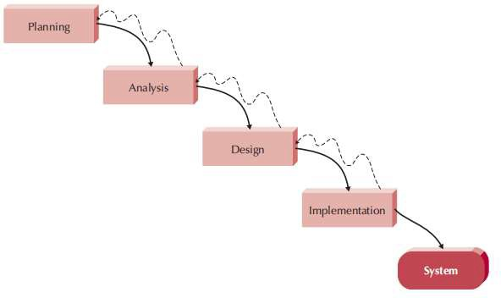

Waterfall Model (Dennis, Wixom and Tegarden, 2005)

• The waterfall model is associated with high costs and efforts, as highlighted by Petersen, Wohlin, and Baca (2009). This is because the model requires a significant amount of documentation and approvals, and changes can be expensive and require significant effort to implement. A survey conducted by Petersen, Wohlin, and Baca (2009) found that a significant amount of documentation is needed during the requirements phase, but much of it is not used in later stages and may need to be discarded or rewritten.

• Changes in requirements can also pose problems when using the waterfall model, as noted by Casteren (2017). The model places a strong emphasis on software specification and does not allow for new requirements or features to be added once they have been finalized and approved by all stakeholders. This can lead to low customer satisfaction, as sudden changes in requirements are not addressed. As a result, the waterfall model is best suited for projects with well-defined requirements that are unlikely to change.

### Agile Methodoly

Agile methodology, which was inspired by the Toyota Production System, is widely implemented in software development projects worldwide. According to Lei et al. (2017), Agile methodology is known for its short development cycles, high customer interaction, and adaptability to change, which distinguishes it from traditional software development models.

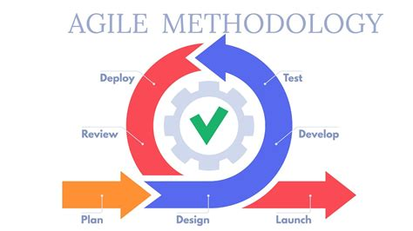

The 2018 13th Annual State of Agile Survey by CollabNet VersionOne found that 69% of respondents use agile to manage changing priorities, 65% of respondents state that agile improves project visibility, and 64% of respondents realize that agile increases the business-IT alignment. This suggests that agile methodology is beneficial for delivering successful software projects. Two popular frameworks for implementing agile methodology are Kanban and Scrum, which will be discussed in the next section.

### Kanban Methodology

• High visibility: The use of a Kanban card wall in project management allows for easy visualization of the current progress of a project. The card wall accurately displays what tasks need to be completed within a given timeframe, with tasks written on colored sticky notes and added to the Kanban backlog. As tasks are completed, they move through different steps until they are fully completed (Lei, et al., 2015).

• Limiting Work in Process (WIP): The Kanban method limits the number of tasks in any step of the card wall, only allowing new tasks to be added if there is available capacity in that step. A queue is used to create slack between steps, and tasks are assigned based on their priority, with the most important tasks receiving the most attention to reduce the risk of incompletion (Lei, et al., 2015).

### Scrum Methodology

According to Scrum framework, the sprint is a fundamental element of the development process. As stated by Lei et al. (2015), each sprint can be viewed as a sub-project, with a clear plan for what needs to be built and how it should be built. Typically, sprints last for 30 days, and the goals for each sprint should not be altered during that time frame. However, if necessary, sprints can be cancelled or the project scope can be redefined to meet customer needs.

Effective sprint management requires frequent meetings to ensure the quality of the product. At the start of each sprint, a sprint planning meeting is held to establish goals and the plan for implementing them. During the sprint execution, daily Scrum meetings are held for 15 minutes, where team members update one another on their progress and any challenges encountered. Additionally, a sprint review meeting is conducted to discuss individual contributions and identify areas for improvement for future sprints. This meeting may also include a product demonstration.

It is important to note that these practices and meetings are heavily influenced by the Scrum framework, and as such it is important to consult the Scrum guide for more information on how to implement it. Additionally, there are other Agile frameworks such as Kanban, which have their own practices and meetings that may be useful in different contexts.

### Comparison of Kanban and Scrum

According to research conducted by Lei, et al. (2017), a survey was administered to assess the perspectives of employees who utilize Kanban and Scrum in their software development projects. The sample consisted of 35 participants, with 21 (60%) respondents having experience using Scrum and 14 (40%) having experience using Kanban. The study's findings revealed that, on average, there were differences in scores for various factors between those who used Kanban versus those who used Scrum. These results are presented in the table provided by Lei, et al. (2017).

Average scores for each factor, for both Kanban and Scrum (Lei, et al., 2015)

|  |  |  |
| --- | --- | --- |
| **Factor** | **Kanban** | **Scrum** |
| Time schedule | 4.05 | 3.67 |
| Clear project scope | 3.68 | 3.60 |
| Budget handling | 3.79 | 3.87 |
| Risk control | 3.93 | 3.83 |
| Available resource | 3.93 | 3.88 |
| Quality of project | 4.02 | 3.98 |

According to the study, Kanban users were found to have a higher level of awareness regarding project status compared to Scrum users, with an average score of 4.36 for Kanban and 3.76 for Scrum. Additionally, the results indicated that Kanban users were better able to adhere to project schedules, with a score of 4.05 for Kanban and 3.67 for Scrum. In terms of scope, budget, risk and resources factors, Kanban also performed slightly better than Scrum, with the difference in average scores being less than 0.1. Both Kanban and Scrum were found to be successful in delivering quality software projects, with scores around 4.0 for the quality factor. These results suggest that Kanban is more efficient than Scrum in terms of schedule, scope, budget, risk, resources, and quality factors, as well as in terms of awareness of project status.

It is important to note that this study is one of many that have compared Kanban and Scrum and their effectiveness in software development projects. Therefore, it is recommended to read and compare with other studies such as (Koch, 2017) and (Sedano & Ruiz, 2018) that also assess the performance of both methodologies.

### Comparison of Waterfall and Agile

Poe and Seeman (2019) conducted a case study to examine the correlation between software development hours and software defects in Waterfall and Agile projects. A total of eight project teams participated in the study, with three of them utilizing the Waterfall method and five implementing Agile. The results of the defect analysis for both project types are presented in the table provided in the original study.

Defect Analysis for Waterfall and Agile Projects (Poe and Seeman, 2019)

|  |  |  |
| --- | --- | --- |
| **Project Methodology** | **Waterfall** | **Agile** |
| Total Combined Development Hours | 3140 | 2076 |
| Total Number of Production Defects | 19 | 21 |
| Total Number of Pre-Production Defects | 43 | 13 |
| Percentage of Production Defects to Development  Hours | 0.61% | 1.01% |
| Percentage of Pre-Production Defects to  Development Hours | 1.37% | 0.63% |

In a study of software development teams, the hours spent on software development and the number of software defects were recorded throughout the entire software development life cycle. The results showed that teams working on a Waterfall project required 3140 development hours to complete the project, which was 1064 hours longer than the Agile project (2076 hours). Additionally, the number of pre-production defects in Waterfall project teams was significantly higher than Agile project teams, with 43 defects in the Waterfall project compared to 13 in the Agile project. This resulted in a higher percentage of pre-production defects to development hours for the Waterfall project (1.37%) compared to the Agile project (0.63%).

However, the total number of production defects for both the Waterfall and Agile projects were similar, with 19 defects in the Waterfall project and 21 defects in the Agile project. When considering the software development hours for both methodologies, the percentage of production defects to development hours was found to be higher for the Agile project (1.01%) than for the Waterfall project (0.61%). This is likely due to the fact that more defects were identified during the pre-production stage for the Waterfall project, resulting in the team spending more time fixing them before the project reached the production stage.

Overall, the results of this case study suggest that while the Waterfall methodology may lead to higher software quality code, it requires a longer software development time for testing.

### Prototyping Methodology

The prototyping methodology involves concurrent analysis, design, and implementation phases to deliver a system prototype for user review. This process can be repeated multiple times until user satisfaction is achieved. According to Dennis, Wixom, and Tegarden (2019), the initial prototype is typically the first part of the system, and it can be re-analyzed, re-designed, and re-implemented to add additional features in each cycle. Once the system prototype has been reviewed and approved by users, the developer can move forward with the actual implementation to develop the final system.

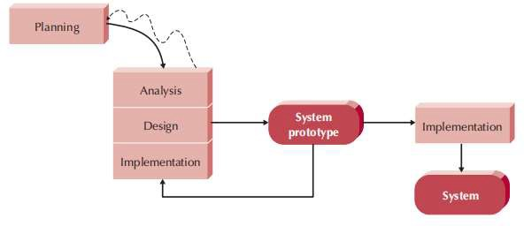

Prototyping Model (Dennis, Wixom and Tegarden, 2005)

One benefit of the prototyping methodology is that errors can be detected earlier. This approach involves a significant amount of user involvement during the development stage, allowing users to interact with the system prototype and provide immediate feedback. This helps to avoid misunderstandings or miscommunications between users and developers about the features of a system, which improves the quality of system specifications provided by users.

However, one potential drawback of the prototyping methodology is that it can lead to excessive development time. The process requires user feedback and recommendations on system prototypes for improvements. Developers may spend a significant amount of time delivering a complex prototype for user review. Additionally, as the prototyping methodology allows users to request changes or enhancements, disagreements from users can lead to an endless loop of re-analyzing, re-designing, and re-implementing in order to achieve user satisfaction. This can cause the project to run over time and budget.

### Conclusion

In contrast to other development methodologies, such as Waterfall or Agile, the prototyping methodology allows for more user involvement and flexibility in the development process. However, it is important to consider the potential for longer development time and potential disagreements from users before selecting this methodology. Ultimately, the choice of software development methodology should be based on the specific needs and requirements of the project, as well as the situation and resources available. In this particular project, the prototyping methodology will be chosen as it allows for earlier detection of errors, better change control, and the development of a more user-friendly system through user involvement.

In conclusion, the prototyping methodology is a widely used approach in software development that has several advantages over other development methodologies. It allows for early detection of errors, improves the quality of system specifications provided by users, and provides an interactive approach that allows users to have a hands-on experience with the system prototype. However, it also has its disadvantages, such as the potential for excessive development time and the possibility of an endless loop of re-analyzing, re-designing, and re-implementing in order to achieve user satisfaction. It is important to consider these factors when deciding whether to use the prototyping methodology for a specific project.

## Existing Lost and Found Systems

This section examines three current lost-and-found systems. We'll talk about and assess these systems' key attributes.

### Crowdfind

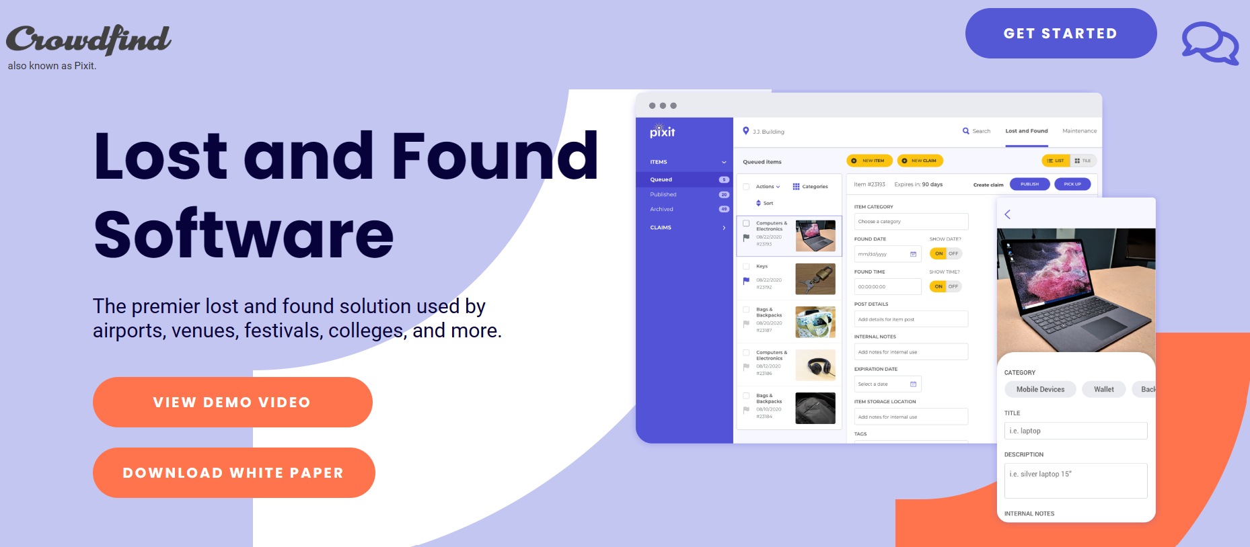

**Crowdfind's primary functions include:**

• Viewing lost and found data

On the site, users may view all lost things. The list only includes item categories and item photos. Users can use any phrase or date to search for a specific item.

• Individualized claim forms

According to the item category, the users are needed to fill out information on the claim forms. They are urged to provide any particular knowledge for the admin to confirm their misplaced things. The likelihood of correctly matching an object increases with the amount of information supplied.

• A chat feature

In order to organize the pickup time and location or request further information from clients, admins may speak with them directly within the system.

Crowdfind is a lost and found system developed by a Chicago-based company. It is popular among universities in the United States, such as the University of Michigan, the University of Iowa, and Texas State University. The system offers several key features, including the ability for users to view lost and found information, customized claim forms, a chat function for communication with administrators, automated reporting, and email notifications.

• Computerized reporting

The dashboard may be used by the system to automatically create reports. These reports can include information such as the number of things that match, the most typical lost goods, and more.

• Email-based alert

After submitting a claim form, consumers will get an email confirmation. They will get an email notification from the system if they hear back from the administrator or if their claim is approved.

### Evaluating Crowdfind

One of the strongest features of Crowdfind is its customized claim forms. The system generates specific questions for different item categories, which helps to ensure that items are returned to their rightful owners. This is because the system verifies claims based on the detailed information provided by users on the claim form. Additionally, the email notification feature is also beneficial as it allows users to confirm their appointments without logging into the system.

However, Crowdfind also has a limitation in that there is not much information provided in the lost and found list. The system only shows item images and categories, making it difficult for users to identify their items accurately. This can lead to many rejected claims as people need more unique information for verification.

Overall, while Crowdfind is a useful system with several key features, it would be beneficial for the system to provide more information in the lost and found list and to implement email notifications for claim forms. This would improve the user experience and make it easier for users to identify and claim their lost items.

### RepoApp

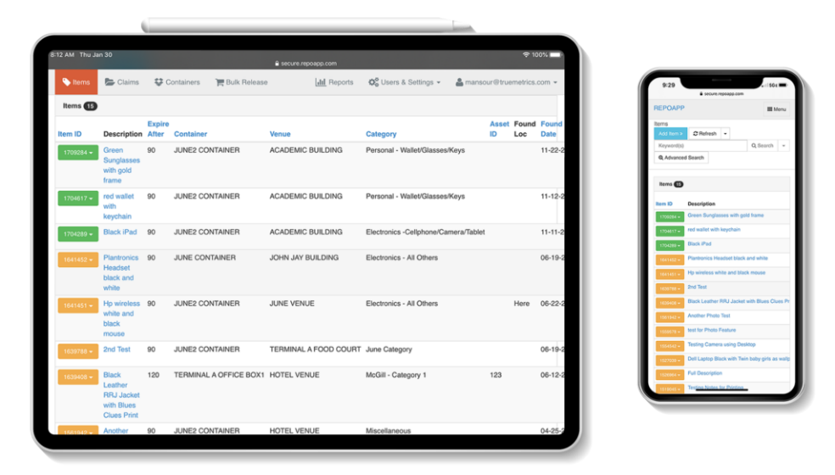

**RepoApp's primary functions include:**

• Viewing lost-and-found data

Users may access information on items that have been lost or recovered, including descriptions, expiration dates, locations, and dates when items were located.

• Email-based alert

By just selecting the email icon, administrators may send emails immediately through the system to a suspected owner. The recipient, topic, and content of the email may all be filled in automatically by the system. If the administrator is not happy with the email contents created, they can change any information before sending it. The email template may also be altered whenever necessary based on the needs.

• Items with auto-match

The technology allows users to search for goods using a variety of parameters. The system will attempt to locate and match each item using the specified criteria. The match list will display any suspected items that fit the criteria so that users can confirm them.

• The return of unclaimed properties

The date that each item expires can be specified by admins. The system will start counting the days until the expiry date when the items have been changed. Any unclaimed things will be taken from the list of lost and found items.

### Evaluating RepoApp

The RepoApp is a web-based lost and found management system that features a user-friendly mobile design. This software allows for integration with an organization's website, enabling all necessary operations to be performed within the organization's website. The National University of Singapore (NUS) currently utilizes RepoApp to manage lost and found items on its campus.

One of the key benefits of RepoApp is its email notification feature for suspected owners. Typically, administrators would need to log into their email accounts and manually compose and send messages to suspected owners. However, with RepoApp, administrators can create custom email templates and the system will automatically send messages based on those templates. This feature significantly reduces the time spent on unproductive tasks by employees.

However, one limitation of RepoApp is that it does not currently include images of lost items in the lost and found information list. This can make it difficult for users to accurately identify their lost items based on the descriptions provided.

In summary, RepoApp's search engine and email notification features for suspected owners are notable benefits that help to reduce information overload and improve the delivery of lost and found information to students. Additionally, RepoApp includes a system for releasing unclaimed items by allowing students to bid on expired items.

### FidoFinder

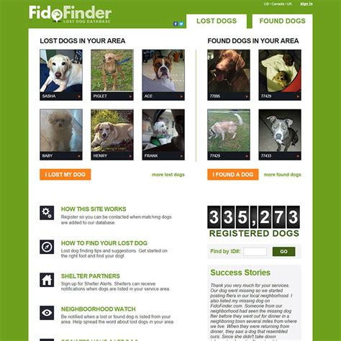

**FidoFinder's primary functions include:**

• Viewing lost-and-found data

Users may browse all photographs of dogs who have been lost or located. The listings will only display photos. To access more specific information, like as color, breed, gender, and more, users should click inside the image. They can use both the postal code and the attributes to search the dog listings.

• The reCAPTCHA validation

Some users may provide their phone number so that others may call them right away. The phone number may be seen by clicking the "View Phone Number" option. Before displaying the phone number, users should verify that they are not a robot by checking the "I'm not a robot" reCAPTCHA checkbox.

• Immediately notifying a mobile application

To obtain immediate notification, users are urged to use mobile applications. After downloading the mobile application, users must sign in to their account and choose "Allow Notifications" when prompted.

• Pre-registration

Despite the fact that the canines are still safe, owners can pre-register them. Dogs in safe listings will be updated by the system. If their canines go missing, users can label the status as "lost." The individual who located the pets has the option to modify their status to "probably safe" and get in touch with the lost dogs' owners.

### Evaluating Fidofinder

According to the latest statistics from FidoFinder.com, as of the date of this report, the website currently has over 1 million registered dogs on its platform. This vast database of registered dogs makes it an invaluable resource for individuals looking to reconnect with their lost pets. The platform's search function, which allows users to filter by characteristics such as breed, color, and location, has also been highly praised for its effectiveness in streamlining the lost and found process.

However, the website's user interface (UI) design has been identified as an area for improvement. Feedback from users has indicated that the lost and found dog listings are not prominently displayed on the homepage, making it difficult for users to quickly access the information they need. In response to this feedback, FidoFinder.com has committed to revamping the website's UI to make the lost and found dog listings more prominently displayed on the homepage, making it easier for users to find the information they need. Additionally, the website's search function is being improved to make it even more user-friendly, with advanced search options being added to allow for more precise filtering of results.

### Comparison of Crowdfind, RepoApp and FidoFinder

Comparison Matrix of Crowdfind, RepoApp and FidoFinder

|  |  |  |  |
| --- | --- | --- | --- |
| Existing System  Features | Crowdfind | RepoApp | FidoFinder |
| View lost and found information | Yes | Yes | Yes |
| Show images | Yes | No | Yes |
| Search and filter function | Yes | Yes | No |
| Customize claim form | Yes | No | No |
| Chat function | Yes | No | No |
| Automated reporting | Yes | Yes | No |
| Email notification | Yes | Yes | No |
| Instant notification to mobile | No | No | Yes |
| Auto-match items | No | Yes | No |
| Release of unclaimed items | No | Yes | No |
| reCAPTCHA verification | No | No | Yes |
| Pre-registration | No | No | Yes |

### Conclusion

In conclusion, the evaluation of various lost and found systems has revealed that each one possesses unique features that serve specific purposes. However, there are also common features such as the ability to view lost and found information. Based on this analysis, it has been determined that Crowdfind offers the most comprehensive features when compared to RepoApp and FidoFinder. The user interface design of Crowdfind is particularly noteworthy, as it is clean and organized, making it easy for users to identify their lost items.

The features that will be implemented in this project include:

i. A card format for viewing lost and found information

ii. The inclusion of item images

iii. A search and filter function

iv. The release of unclaimed items after a certain period of time

v. Email registration and verification

The implementation of these features will likely increase the willingness of students to report lost items and actively engage with the system. The search and filter function will allow students to quickly locate the information they need, while the release of unclaimed items will open them up for bidding after a certain period of time. Additionally, the email registration and verification process will enhance the security and authenticity of the system.

# CHAPTER 3: METHODOLOGY (MODELING AND DESIGN)

## Introduction

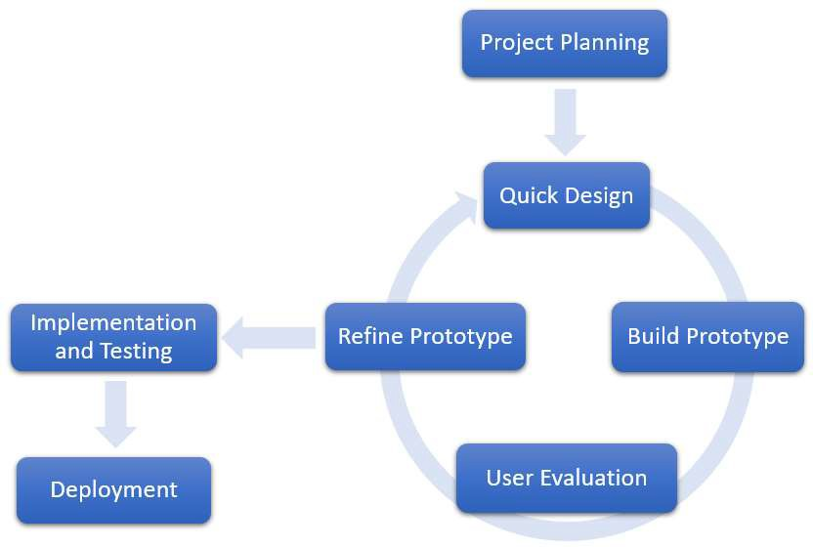Prototyping technique is the software development methodology employed in this project. The prototype methodology model is depicted in the image below.

The project design phase, iteration process, implementation, testing, and deployment are the four main stages that make up the prototype approach. In the section that follows, the specific tasks associated with each phase will be covered.

## Planning Project

Plans were created during the project planning process. To guarantee that the project can be completed within the allotted time and scope, all project tasks were planned and scheduled. To define the project scope and depict the project timetable, the Work Breakdown Structure (WBS) and Gantt chart were created. In addition, a survey was carried out to gather the needs. The survey's analysis may be used to establish the software requirements and development tools. Additionally, a rapid concept for a system storyboard was created.

## Workflow Organization (WBS)

This project's tasks are broken down into several smaller jobs and arranged according to the WBS. There are particular duties in each phase that must be finished before going on to the next. The WBS for this project is depicted in the picture below.

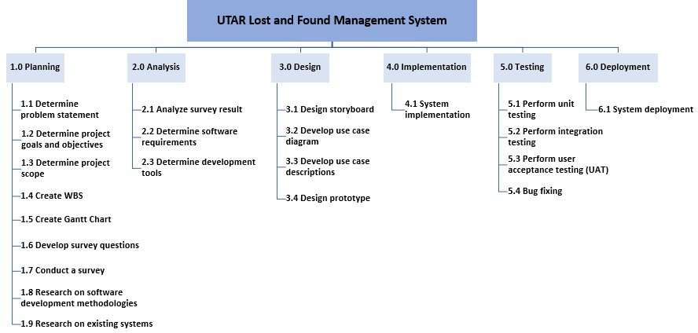

Ifinder Lost and Found Management System

## Gantt Chart

A Gantt chart is a tool used to plan and schedule all of the subtasks within a project, based on their respective durations. By utilizing this method, a comprehensive and easily understood project schedule can be created using a Work Breakdown Structure (WBS). In the current project, a Gantt chart was constructed covering the time frame of January to August. The illustration below illustrates the Gantt chart used in this project.

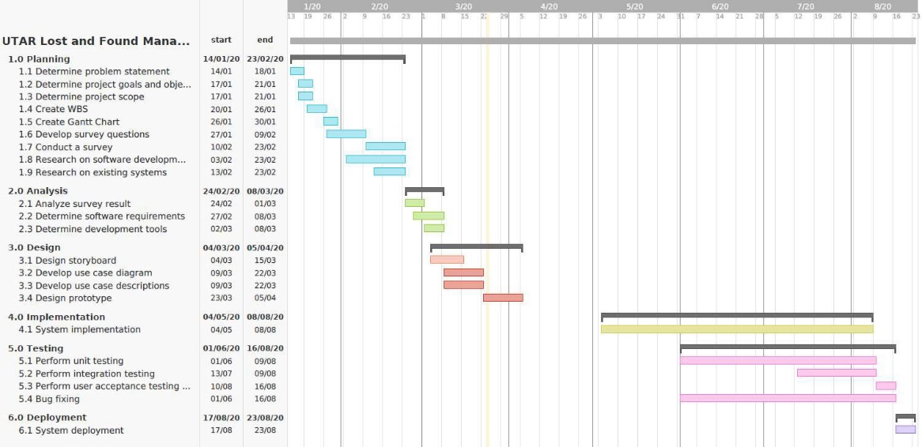

Ifinder Management System

## Survey Analysis

The are parameters of survey carried out to obtain data on requirements.

### Web application or Mobile application?

If you were to choose a platform for Ifinder lost and found management system what would it be; web application or mobile application?

For 30 respondent (Course mates in Bsc IT class, distance eduction)

According to the pie chart above, 53.3% of respondents prefer to utilize online apps while 46.7% prefer to use mobile applications to get lost and found information. The percentage of online applications and mobile applications is practically the same, as can be shown. Because they do not require the installation of another software on a mobile device, some respondents prefer to utilize online apps. Some respondents, however, prefer mobile applications since they can retrieve the lost and recovered data whenever and wherever they are. A cross-platform application may be created as a result to satisfy the demands of each respondent.

### What characteristics are you looking for in a lost-and-found application?

30 respondents

1. A feature that allows for notifications to be sent when lost items are found has been implemented in the system.
2. This feature should include the ability to organize and filter items, view who has claimed an identification, and access information about the return of a lost identification card.
3. The system also includes a search function, allowing users to search for items by keywords, filter and sort through results, and check the current status of items.
4. Users can also tag other users for added convenience. Photos of lost and found items are also displayed for easy identification.
5. Additionally, people can directly post advertisements for lost identification card within the app, eliminating the need to rely on the department.
6. System should include no registration. Moreover, users who have lost an item can also upload details of their identification card to aid in its recovery.
7. The system allows users to search for lost items using keywords, and provides contact information for the finder of the item.
8. The user interface is user-friendly and easy to use. Users can post lost and found items and have the ability to view and update them immediately.
9. The system also includes an item filter feature that allows for better search results and the ability to match a lost item's image.
10. Users can also view the location of their lost item and schedule appointments to retrieve it at the pickup office.
11. Additionally, the system organizes all items in one convenient application, and includes rules for disposing of unclaimed items.
12. Users who have lost an item can also upload details of their identification cards to aid in the search.

Main Expected Features in Lost and Found Application

|  |  |
| --- | --- |
| Expected Features | Number of Respondents |
| Clear and well-organized lost and found  information | 13 (43.3%) |
| Search and filter items | 8 (26.7%) |
| Allow people to report lost and found items | 3 (10.0%) |
| User-friendly interface | 2 (6.7%) |
| High accessibility | 2 (6.7%) |
| Make appointment before claim back items | 1 (3.3%) |
| Notification | 1 (3.3%) |

According to the data presented in Table above, the majority of respondents (43.3%) emphasized the importance of a clear and well-organized presentation of lost and found information in the application, to improve their ability to view all items. Additionally, a significant number of respondents (8) considered search and filter functions to be crucial in a lost and found application. Furthermore, a few respondents (3) suggested allowing people to report lost and found identification cards on the application, as it would encourage people who may otherwise be reluctant to hand over items to the pickup offices. This would increase the willingness of people to report lost items around Ghana. Other suggestions from respondents included a user-friendly interface (2), high accessibility system (2), the ability to make appointments before claiming items (1) and a notification function (1).

## Tools for Development

The system was implemented in this project using a variety of technologies for web application. In this part, all development tools will be covered.



**CSS**

**XAMPP Server**

XAMPP Server

Wamp Server is a web development platform that allows us to create a dynamic web application with Apache, PHP and MySQL (WampServer, n.d.). The features of Apache, PHP and MySQL are explained below.

* + - * + Apache
        + PHP
        + MySQL
        + CSS

XAMPP Server is a popular web development platform that allows developers to create dynamic web applications using a combination of Apache, PHP, and MySQL.

Apache is a HTTP web server that is responsible for handling requests and responses between the client and the server. It is the foundation of the XAMPP server and enables the other tools to function properly.

PHP is a scripting language that is widely used in web development. It is a server-side language that allows developers to create dynamic web pages and interact with databases. In XAMPP, PHP is used to execute scripts on the server side, which can be used to process forms, display data from a database, and many other tasks.

MySQL is a powerful relational database management system that is used to store and retrieve data. It is an essential component of XAMPP as it allows developers to create and manage databases for their web applications.

CSS (Cascading Style Sheets) is a language that is used to style an HTML document. It allows developers to separate the presentation from the content of the web page, making it easier to update and maintain. In XAMPP, CSS is used to create visually appealing designs for web pages.

Overall, XAMPP Server is a comprehensive development tool that allows developers to create dynamic web applications using Apache, PHP, MySQL, and CSS. These tools work together to enable developers to handle requests and responses, create dynamic web pages, manage databases, and style web pages.

## Quick Design.

### Front-End

**Home Page**

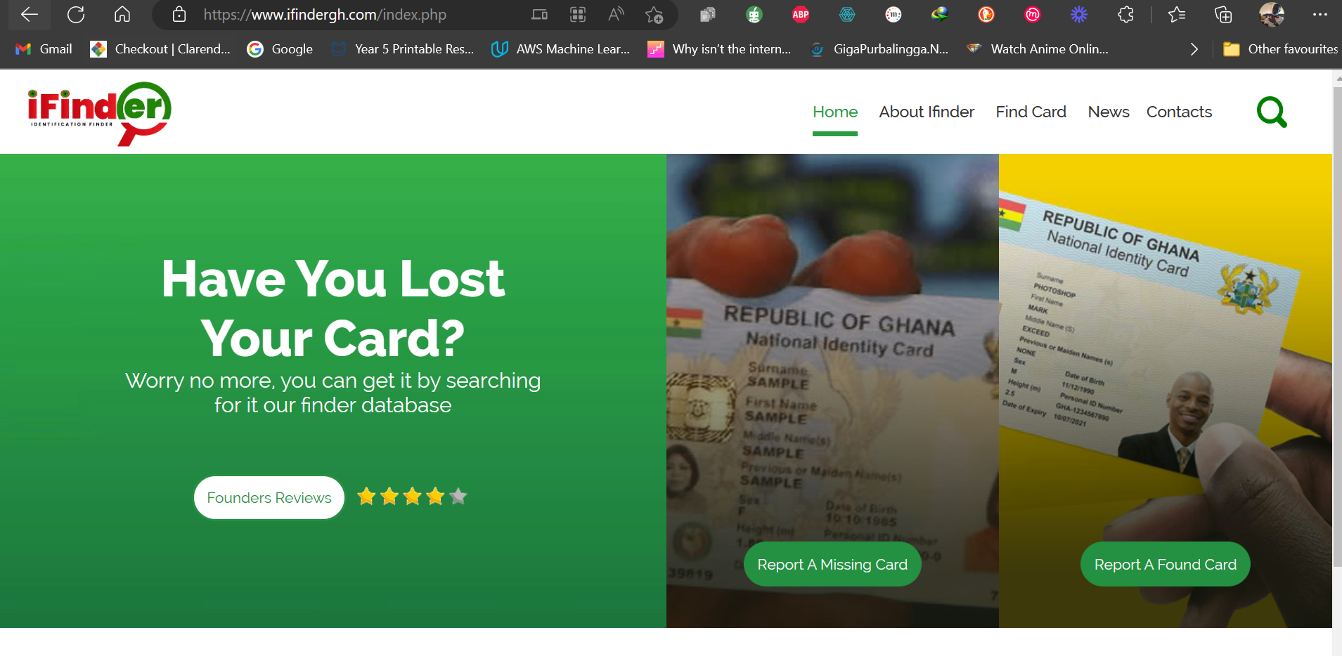

The homepage of ifindergh.com is a clean and simple design that displays the main features of the website. The top of the homepage features a navigation bar with links to the different sections of the website, including “Home”, “About Ifinder”, “Find Card”, “News”, “Contact”

The body of the homepage features "Founders Review", "Report A Missing Card", "Report Found Cards".

**Founders review**: It provides option for user to rate and give comments about Ifinder.

**Report A Missing Card:** The provides users with a form to provide details on their missing identification cards.

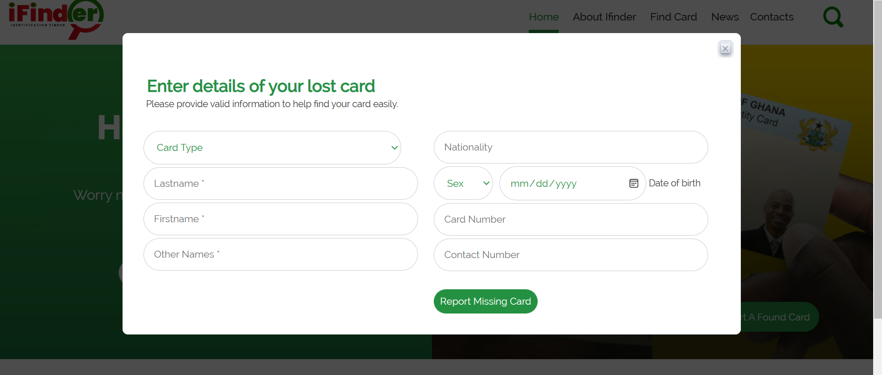

**Report A Found Card:** This provides users with a form to complete on the details of the found card and also the founders contact for easy retrieval.

### Back-End

**Admin Dashboard Login Page**

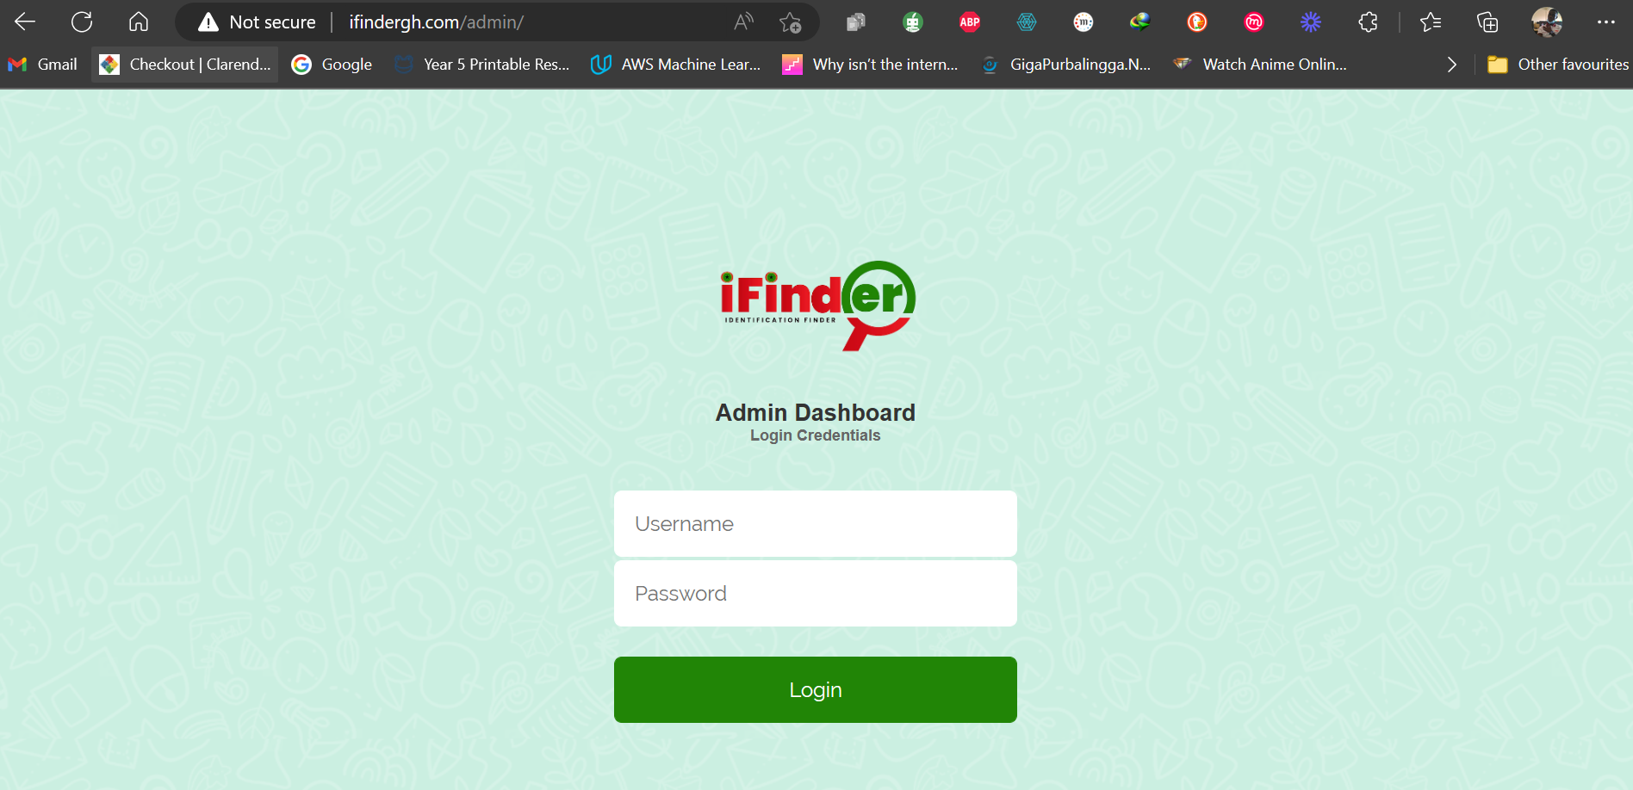

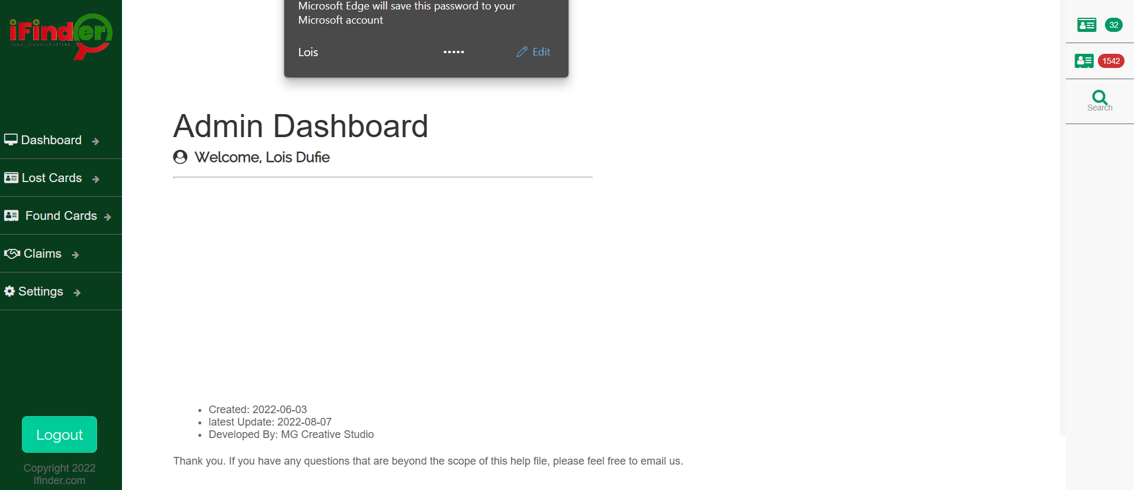**Admin Dashboard Homepage**

**Lost Card Database**

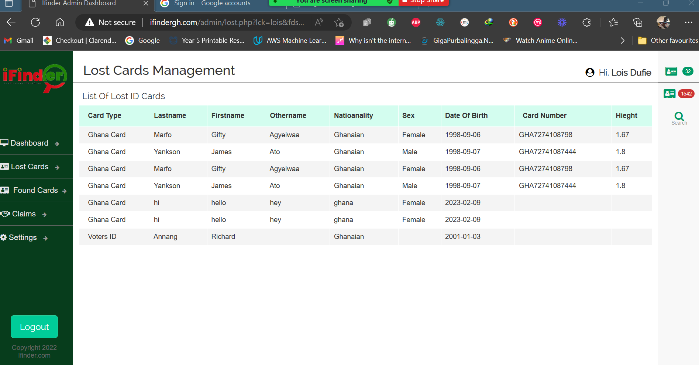

Found Card Database

# CHAPTER 4: SYSTEM IMPLEMENTATION

## Introduction

iFinder is a web application and a lost and found management system that is designed to help Ghanaians track their lost identification cards. The system is easy to use and allows users to quickly report lost items and search for found items. This document outlines the process for implementing the iFinder system, including hardware and software requirements, system installation, software testing, debugging, user training, maintenance, and system documentation.

## Hardware and Software Requirements

The iFinder system requires the following hardware and software:

A web server with a minimum of 2GB of RAM and 2GHz of processing power

A MySQL database server

PHP version 7.0 or higher

Apache web server

A modern web browser

## System Installation

The iFinder system can be installed by following these steps:

Install the web server, MySQL server, PHP and Apache on the server

Download the iFinder source code from the official website

Configure the web server and database settings in the source code

Create a new MySQL database for the iFinder system

Import the iFinder database schema into the new database

Configure the database settings in the iFinder source code

Test the iFinder system by accessing it in a web browser

## Software Testing

The first step in the implementation of iFinder is to test the software to ensure that it is free of bugs and errors. This will include functional testing, performance testing, stress testing, and structure testing. The functional testing will ensure that the system works as intended and that all features are functioning properly. Performance testing will ensure that the system can handle a high number of users without any issues. Stress testing will ensure that the system can handle extreme loads. Structure testing will ensure that the system is well-organized and easy to navigate.

### Functional testing

Functional testing will be carried out to ensure that the system works as intended and that all features are functioning properly. This will include testing the system's search and filter functions, as well as testing the ability to report lost items and claim found items.

### Performance testing

Performance testing will be carried out to ensure that the system can handle a high number of users without any issues. This will include testing the system's response time, as well as testing the system's ability to handle large amounts of data.

### Stress testing

Stress testing will be carried out to ensure that the system can handle extreme loads. This will include testing the system's ability to handle a high number of users, as well as testing the system's ability to handle large amounts of data.

### Structure Testing:

The first step in implementing the iFinder system is to test the structure of the system. This includes testing the database and the server to ensure that they are properly configured and able to handle the expected load. It also includes testing the user interface to ensure that it is easy to use and navigate. This step is important to ensure that the system is stable and reliable before it is released to the public.

## Debugging:

Once the structure testing is complete, debugging is done to fix any errors that were found during the structure testing. This includes fixing any bugs in the code, as well as any issues with the database or server. This step is important to ensure that the system is free of errors and is functioning as expected.

## USER Training:

After the system is debugged, user training is conducted to ensure that users are able to use the system effectively. This includes providing training on how to search for lost or found items, how to report lost items, and how to claim found items. This step is important to ensure that users are able to use the system with minimal assistance.

## Maintenance:

Once the system is released to the public, regular maintenance is performed to ensure that the system remains stable and reliable. This includes monitoring the system for any errors or issues, as well as making updates and upgrades as necessary. This step is important to ensure that the system remains up-to-date

## System Documentation

The first step in implementing the iFinder system is to create comprehensive system documentation. This documentation should include technical specifications, user manual, and system flow diagrams. The technical specifications should include details on the software and hardware requirements for the system, as well as any security measures that will be implemented. The user manual should provide clear instructions on how to use the system, including how to report lost cards, search for lost cards, and claim found cards. The system flow diagrams should provide a visual representation of the system's functionality and how different components interact with each other.

## Conclusion

In conclusion, the implementation of the Ifinder system as a web application and lost and found management system for identification cards in Ghana has proven to be a valuable tool for managing lost and found identification cards in the country. The system's features such as the ability to view and search for lost and found identification cards, claim lost identification cards, report lost identification cards, and book unclaimed identification cards, have made it easier for Ghanaians to locate and return lost identification cards to their rightful owners. The implementation of the system has also been successful thanks to the use of a feature-driven iteration process, which allowed for the development of new features and the refinement of existing ones. Additionally, thorough testing was carried out to ensure that the system met the requirements of users and that it was of high quality. Overall, the system has helped to improve the efficiency of lost and found management of identification cards in Ghana and has made it easier for people to locate and return lost identification cards.

# CHAPTER 5: CONCLUSION.

The proposed study aimed to design and develop a web-based application, iFinder, to address the challenges associated with the current lost and found management procedures for identification cards in Ghana. The study was conducted to evaluate existing practices for Lost and Found Management Systems and identify issues such as inconvenient lost and found procedures, scattered and unorganized lost and found information, and failure to deliver the latest lost and found information to individuals. Furthermore, the restriction of access to facilities and services without a valid identification card can have a significant impact on an individual's daily life.

The proposed solution included the implementation of a cross-platform iFinder application that offered a standardized and centralized approach for managing lost and found identification cards in Ghana. The design of the application aimed to enhance the efficiency and effectiveness of managing and organizing lost and found identification cards in Ghana. The proposed solution was tested and evaluated on the population of Ghana.

The evaluation of the iFinder application revealed that it simplified the lost and found process and increased the efficiency of identifying and organizing lost and found identification cards. It also improved the deliverability of lost and found information to individuals and increased the chances for the owners to claim back their items. Additionally, the application allows individuals to use both web browsers or mobile devices to access lost and found information anytime, increasing efficiency.

In conclusion, the proposed study has provided a comprehensive approach to addressing the challenges associated with the current lost and found management procedures for identification cards in Ghana. The proposed iFinder application offers a centralized and user-friendly solution to reporting and claiming lost identification card.

# CHAPTER 6: REFERENCES

Ahmad, S., Ziaullah, M., Rauniyar, L., Su, M. and Zhang, Y., 2015. How Does Matter Lost and Misplace Items Issue and Its Technological Solutions in 2015 - A Review Study. *IOSR Journal of Business and Management Ver . I*, 17(4), pp.2319–7668.

Aldaej, R., Alfowzan, L., Alhashem, R., Alsmadi, M.K., Al-Marashdeh, I., Badawi, U.A., Alshabanah, M., Alrajhi, D. and Tayfour, M., 2018. Analyzing, Designing and Implementing a Web-Based Auction online System. *International Journal of Applied Engineering Research*, *13*(10), pp.8005-8013.

Android Studio, n.d. [online] Available at: <https://developer.android.com/studio> [Accessed 16 February 2020].

Atom, n.d. [online] Available at: <https://atom.io/> [Accessed 16 February 2020].

Casteren, W.V., 2017. The Waterfall Model and the Agile Methodologies: A comparison by project characteristics. *Academic Competences in the Bachelor 2*, pp.10-13. DOI: 10.13140/RG.2.2.10021.50403.

CollabNet VersionOne, 2019. *The 13th annual SATE OF AGILE REPORT - 2018*. CollabNet | VersionOne 13, 16.

Crowdfind, n.d. [online] Available at:

<https://uiowa.v2.crowdfind.com/public/#/dps/items> [Accessed 13 February 2020 ].

Dennis, A., Wixom, B.H. and Tegarden, D., 2005. *System Analysis and Design with UML Version 2.0.* 2nd ed. New York: John Wiley & Sons.

FidoFinder, n.d. [online] Available at: < https://[www.fidofinder.com/](http://www.fidofinder.com/)> [Accessed 13 February 2020].

Hong, Y., Wang, C. and Pavlou, P.A., 2016. Comparing open and sealed bid auctions: Evidence from online labor markets. *Information Systems Research*, *27*(1), pp.49-69. Ilonka, C., 2017. *An Online Auction System for Selling Fiber Products*. Master. Johannes Kepler University Linz. Available at:

<<http://www3.risc.jku.at/publications/download/risc_5873/Lenzing%20Global%20A> uction%20Portal%20-%20M.Sc.%20Thesis%20-%20Csaba%20Ilonka.pdf> [Accessed 10 July 2020].

Kaluža, M., Kalanj, M. and Vukelić, B., 2019. A comparison of back-end frameworks for web application development. *Zbornik Veleučilišta u Rijeci*, 7(1), pp. 317–332. Doi: 10.31784/zvr.7.1.10.

Laravel, n.d. [online] Available at: <https://laravel.com/> [Accessed 16 February 2020] Lei, H., Ganjeizadeh, F., Jayachandran, K. and Ozcan, P., 2017. A statistical analysis of the effects of Scrum and Kanban on software development projects. *Robotics and Computer-Integrated Manufacturing.* Elsevier, 43, pp. 59-67. DOI: 10.1016/j.rcim.2015.12.001.

Nacheva. R., 2017. Prototyping Approach in User Interface. *2nd Conference on Innovative Teaching Methods*, pp. 80-87.

Nicu, C.C., Maria, R.E., Pavel, I.D.D. and Pólkowski, Z., 2014. E-auctions from the Automotive Perspective. *Zeszyty Naukowe Dolnośląskiej Wyższej Szkoły Przedsiębiorczości i Techniki. Studia z Nauk Technicznych*, 3, pp.129-145.

Petersen, K., Wohlin, C. and Baca, D., 2009. The Waterfall Model in Large-Scale Development. *Lecture Notes in Business Information Processing*, 32, pp.386-400. DOI: 10.1007/978-3-642-02152-7_29.

Poe, L.F. and Seeman, E., 2019. An Empirical Study of Post-Production Software Code Quality When Employing the Agile Rapid Delivery Methodology. pp. 1-8.

React Native, n.d. [online] Available at: <https://reactnative.dev/> [Accessed 16 February 2020].

RepoApp, n.d. [online] Available at: < https://[www.repoapp.com/](http://www.repoapp.com/)> [Accessed 13 February 2020].

Tunajek, S.K., 2009. A Place for Stuff : Clutter Can Be Hazardous to Your Health.

*WELLNESS MILESTONES*, [online] Available at:

<https://[www.aana.com/docs/default-source/wellness-aana.com-web-documents-](http://www.aana.com/docs/default-source/wellness-aana.com-web-documents-) (all)/a-place-for-stuff-clutter-can-be-hazardous-to-your- health.pdf?sfvrsn=e12c4bb1_2> [Accessed 15 February 2020].

Yang, F., 2013. *How to Migrate from Waterfall Development Approach to Agile Approach.* Master of Science. Chalmers University of Technology. Available at: < https://odr.chalmers.se/bitstream/20.500.12380/188289/1/188289.pdf > [Accessed 24